AI Usage in the Development of Trivora

Introduction
During the development of Trivora the following tools were used to enhance productivity, debug the errors and generate logos, images.

1. GitHub Copilot (Code Assistance)
GitHub Copilot, powered by OpenAI’s Codex, was used for code generation and suggestions in Kotlin and Jetpack Compose.
Manner of Use: - Assisted in writing code for the Activities and ViewModels.
Benefits: Helped our team complete code faster with helpful assistance

2. DeepSeek
DeepSeek was employed to help implement the multi-language feature by providing me code to implement in my LocaleHelper Class as well as providing me translations from English to Afrikaans.
This translated text was used in the values/strings.xml.
This benefited me by decreasing the time I have to spend on translating words from English to Afrikaans but would sometimes get information wrong
DeepSeek also helped debug problems we had with the dependency’s versions in the gradle.
Helped fix problems in the Layout of the mainActivity.
DeepSeek Link: https://chat.deepseek.com/

3. Gemini
Gemini was used to generate the following images for the Trivora application:

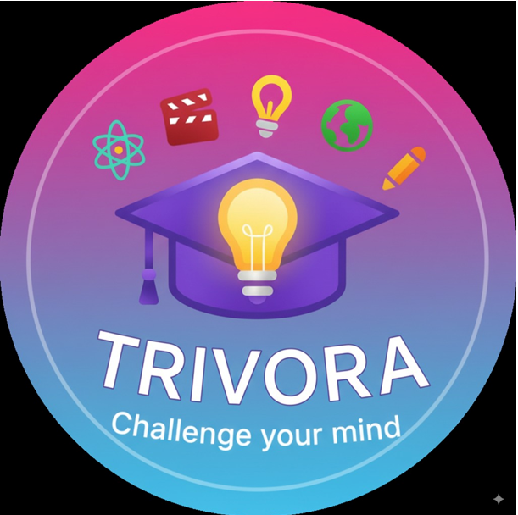

Gemini Chat Link: https://gemini.google.com/app/a8c94a6d807a92a1

